NATS VANCOUVER - FALL WORKSHOP
Introduction to Alexander Technique
with
Gabriella Minnes Brandes

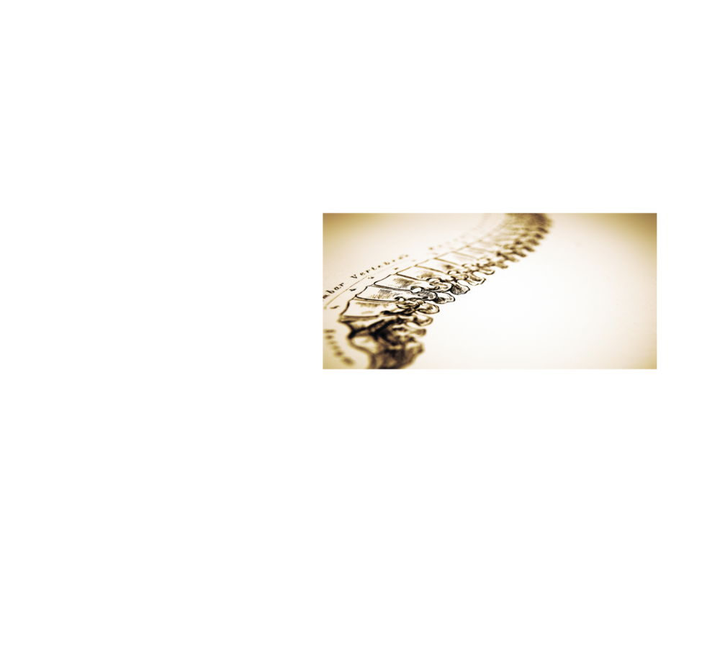

Sunday, November 6th - 3:00-5:30pm
Spirit of Life Lutheran Church - 375 W.10th Ave., Vancouver, BC

General Admission - $24
Payments online - go to ‘Events’ and click on the Paypal button.
General admission payments also accepted at the door with cash or cheque.
Singer Participants - $28 (approx. 6 singers)
Individual singers will work with Gaby approx. 20 min. each.
Pre-registration is required, on a first come, first serve basis. Payments by cheque.
A pianist will be provided. Please bring sheet music.
To register as a Singer Participant please email
Geordie Roberts at alexsson@telus.net

Gabriella Minnes Brandes, Ph.D. has been teaching the Alexander Technique since 1988 and is currently teaching the Technique both in the Theatre Department at Capilano University and at the Alexander Technique Centre. Gaby also teaches in the Young Artists Program at the Vancouver Opera, Opera Nuova (Edmonton) and at the Pender Island Flute Retreat.

Gaby works extensively in collaboration with voice, movement and acting instructors, focusing on the application of the Alexander Technique, as performers are encouraged to explore, experiment with, and reflect on their habitual patterns, and seek effective and efficient ways of using themselves and their voice to enhance their training and performance.

Much of Gaby's current work and research focuses on exploring the connections between Alexander Technique and creativity as it pertains to performers. Informed by her Ph.D. and research in education, she is also exploring the connections between current educational research and Alexander teacher training.

Member of CANSTAT, STAT and AmSAT; co-director of the Vancouver School of the Alexander Technique teacher-training program; and currently the President of the Canadian Society of Teachers of the Alexander Technique, Gaby has shared her work in many conferences and Alexander teacher training courses. For more information see http://alexandertechniquecentre.ca

